How to Register for a Class
- Go to the Missouri State University-West Plains Website (https://wp.missouristate.edu)
- Click on “Log in” at the top right of the screen.
- Click on My Grizzly Den (https://mygrizzlyden.missouristate.edu) in the drop down menu
  - Login with your MSU-WP account (abc123s@login.missouristate.edu) and your current password
- Click the three lines in the upper left corner
- Go to Student
- Locate the Registration Card (If you do not see the Registration card, search for it on the Find card area)
- Click on the “Add, Drop or Search for a class” link
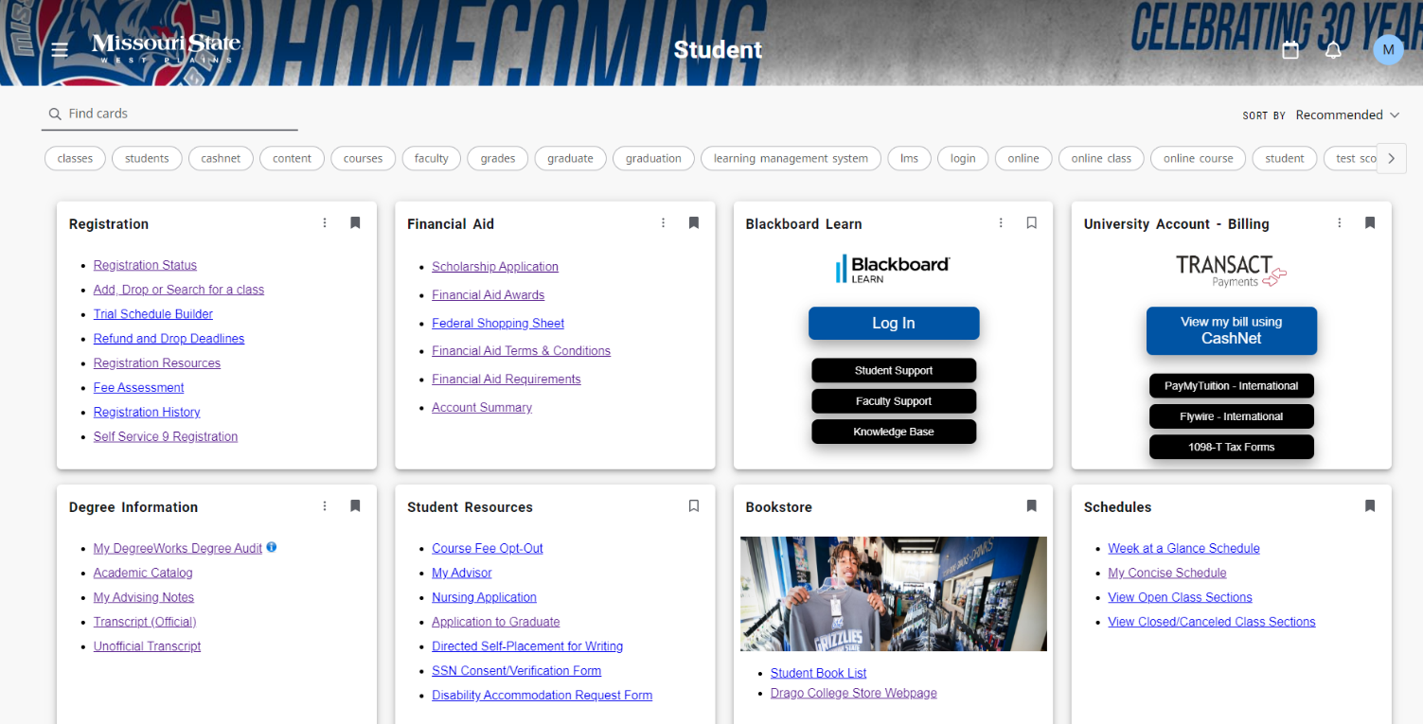
- Login with your MSU-WP account (abc123s and current password)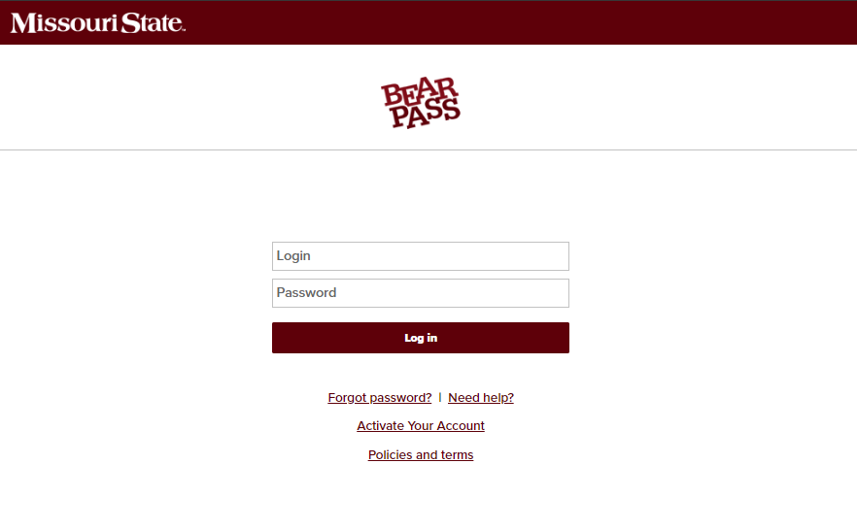
- Select the current term from the drop-down menu
- Click on the “Register or Drop a Course” Link
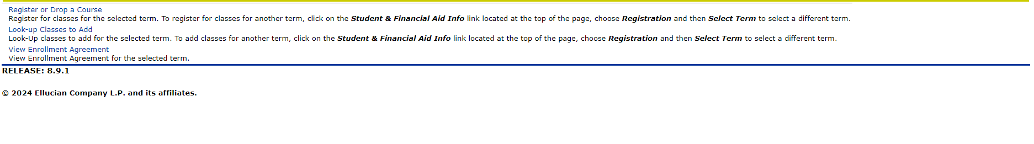
- At the bottom of the screen enter the CRN for the class, if you have it
- OR click on Class Search to find open section of the courses you need

- Choose a subject and click on Course Search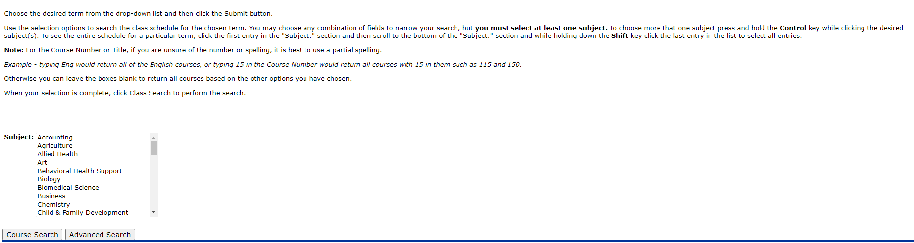
- Once desired class is chosen, click on View Sections
- Click on “Register” located at the bottom of the screen.

