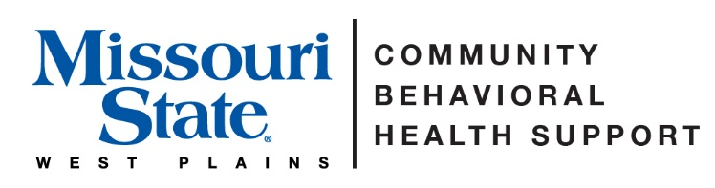

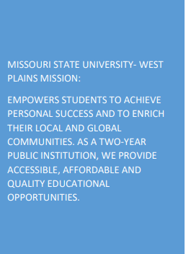

Approval and Accreditation:

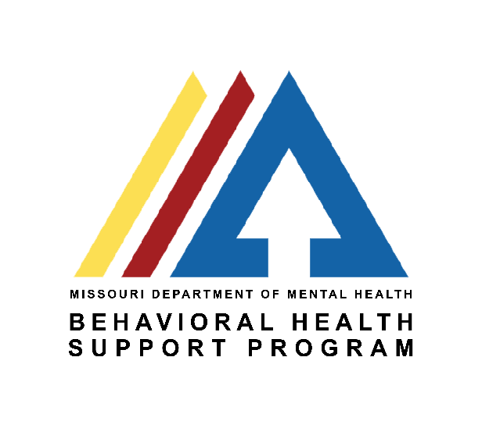
MSU-WP received designation in accreditation process with Missouri Behavioral Health Council and Department of Mental Health.

Contact Information:

Elizabeth Mahan, MSW, LCSW
Program Coordinator/Lecturer for Community Behavioral Health Support
417-255-7253
emahan@missouristate.edu

Amy Ackerson, MSN, RN
Associate Dean for Nursing and Allied Health
417-255-7247
amyackerson@missouristate.edu

Marcella Bean, AS
Nursing and Allied Health Academic Administrative Assistant III
Nursing Admissions Coordinator
417-255-7739
mbean@missouristate.edu

Program Description
The Associate of Applied Science in Behavioral Health Support (BHS) program will provide students with the education and skills needed to work in a variety of behavioral health or substance abuse support roles. Students will receive specialized training and hands-on practicum experiences for entry-level positions such as care coordinators, community support specialists, and case managers. Upon completion of the program, students will have the required skills to provide quality case management to clients in a variety of settings who need guidance and support.
Students will be able to properly complete client documentation from intake to discharge including assessments, safety plans, treatment plans, and discharge summaries. They will be able to utilize case-management skills for clients in the areas of behavioral health, substance abuse disorders, chronic health, and family and youth issues. Students will be qualified to work with other behavioral health and medical professionals as part of a treatment team. Most importantly, students will know how to work within their own competency to provide services to those in need by valuing the dignity and worth of each client and recognizing the importance of the human relationship.
Graduates will be prepared to begin working immediately in state, county, and local human service agencies, substance abuse treatment programs, rehabilitation centers, correction facilities, retirement facilities and schools along with a variety of other human service agencies.

Program Mission Statement:
The Associate of Applied Science in Behavioral Health Support (BHS) program will provide students with the education and skills needed to accommodate diverse client populations with competent services in a variety of behavioral health and substance abuse support roles.

Program Vision:
Missouri State University-West Plains Behavioral Health Support program will provide Missouri communities with professional, compassionate, and competent team members who will go on to become leaders in their field.

Behavioral Health Support Program Standards and Graduate Outcomes:
BEHAVIORAL HEALTH SUPPORT PROGRAM STANDARDS
1. Communication
2. Critical Thinking
3. Health Information Management/Evidence Based Practice
4. Valuing Professional Accountability
5. Culturally Competent Care

PROGRAM OBJECTIVES
Upon completion of the program, the graduate will:
- Use knowledge and skills to collaborate within the helping fields, including mental health, behavioral health, substance use, and human services, for the purpose of client-centered advocacy.
- Demonstrate ability to think critically when coordinating and managing client care using ethical guidelines and culturally sensitive care within the helping fields.
- Demonstrate the ability to implement assessment, treatment plan, and progress notes to effectively assist as care coordinator in mental health, behavioral health, and substance use field.
- Implement effective verbal and nonverbal communication with individuals from a variety of cultural backgrounds.
- Utilize various information systems, including evidence-based practice, for problem solving, decision making, and improving quality of client care.
Course Progression Policy:

The BHS program is set up as a cohort model, so each semester of classes must be passed with at least a “C” or better to progress to the next semester. Students must pass all courses with a “C” or better to graduate with an Associate of Applied Science in Community Behavioral Health Support.

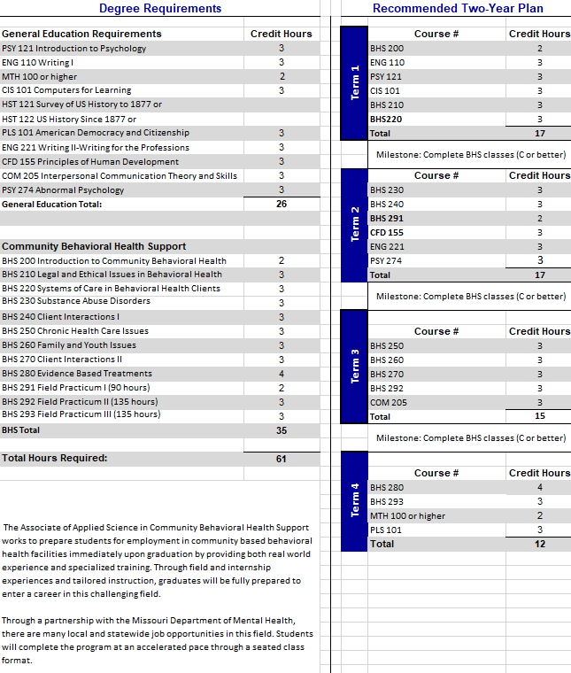

Program Requirements :

• Complete background check
• Pass drug screen
• Be in good academic standing with C or greater in each class.
• Follow HIPAA guidelines and be ethical and professional in conduct.

