Attendance Tracking

- Open the Grizzly Den and choose the My Teaching/Advising tab. In the upper left corner you will see a blue button that says Attendance Tracking.
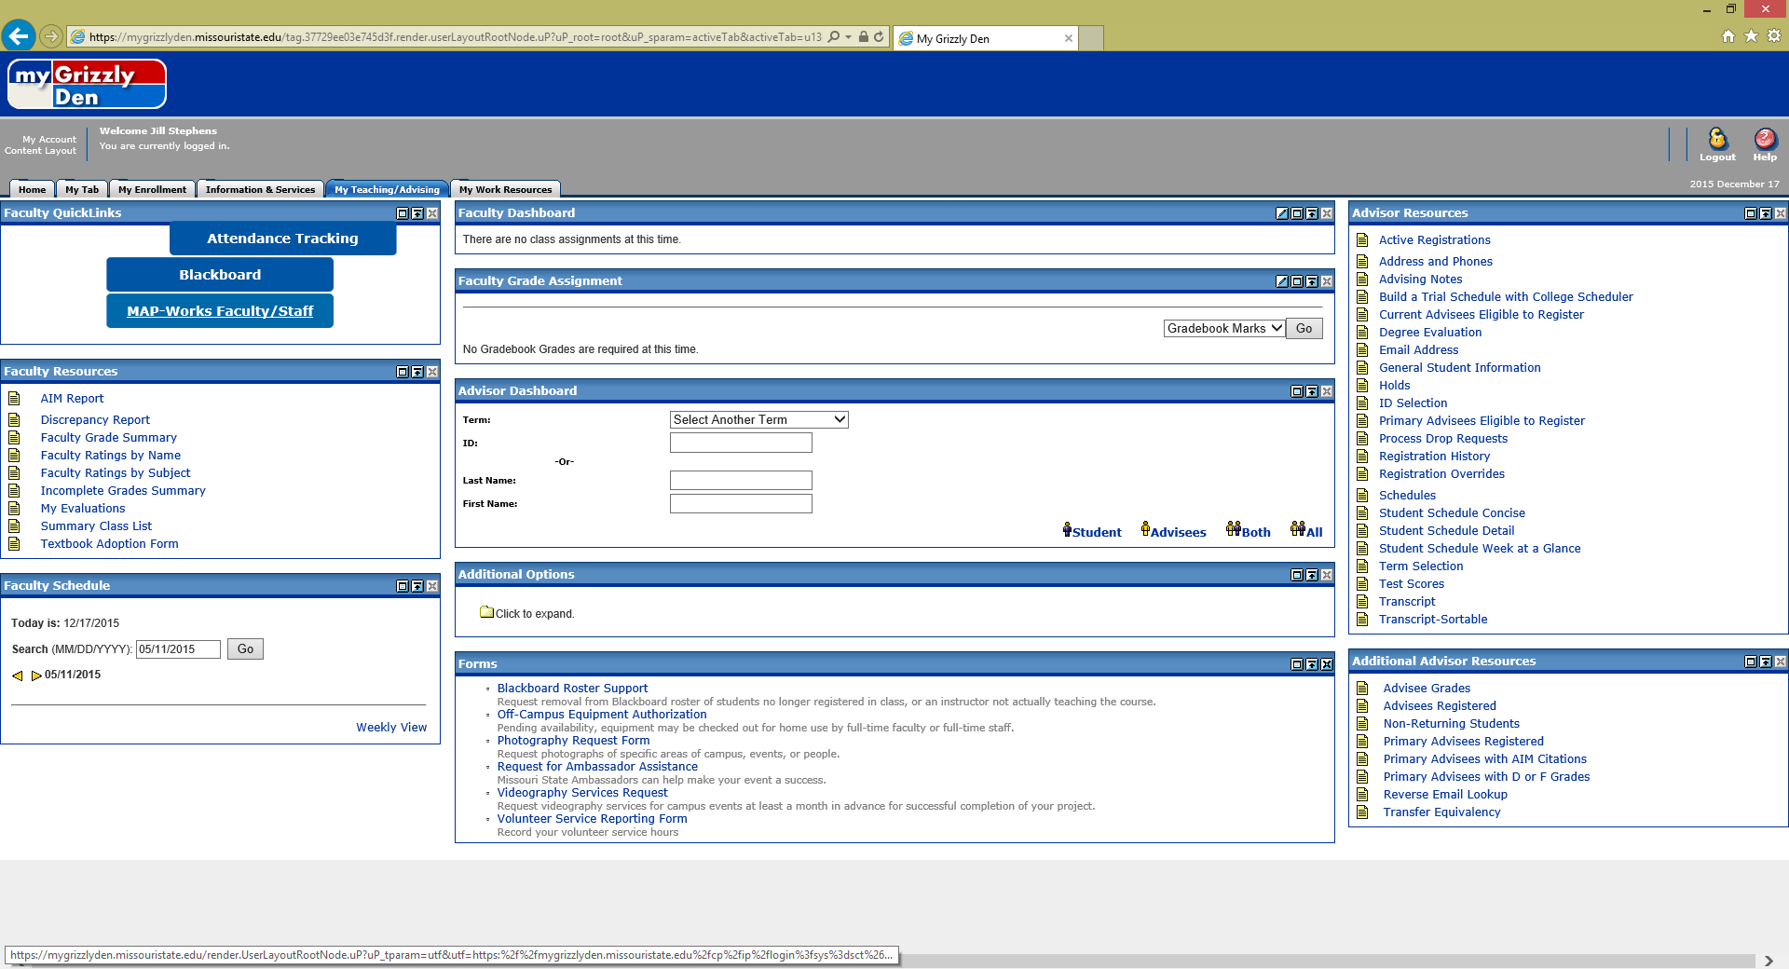

- You will be directed to the Attendance Tracking module where you will see the courses for which you are the instructor for the current term. Note: you can see quite a lot of information about your class under the Course Details tab on the right hand side of the screen.
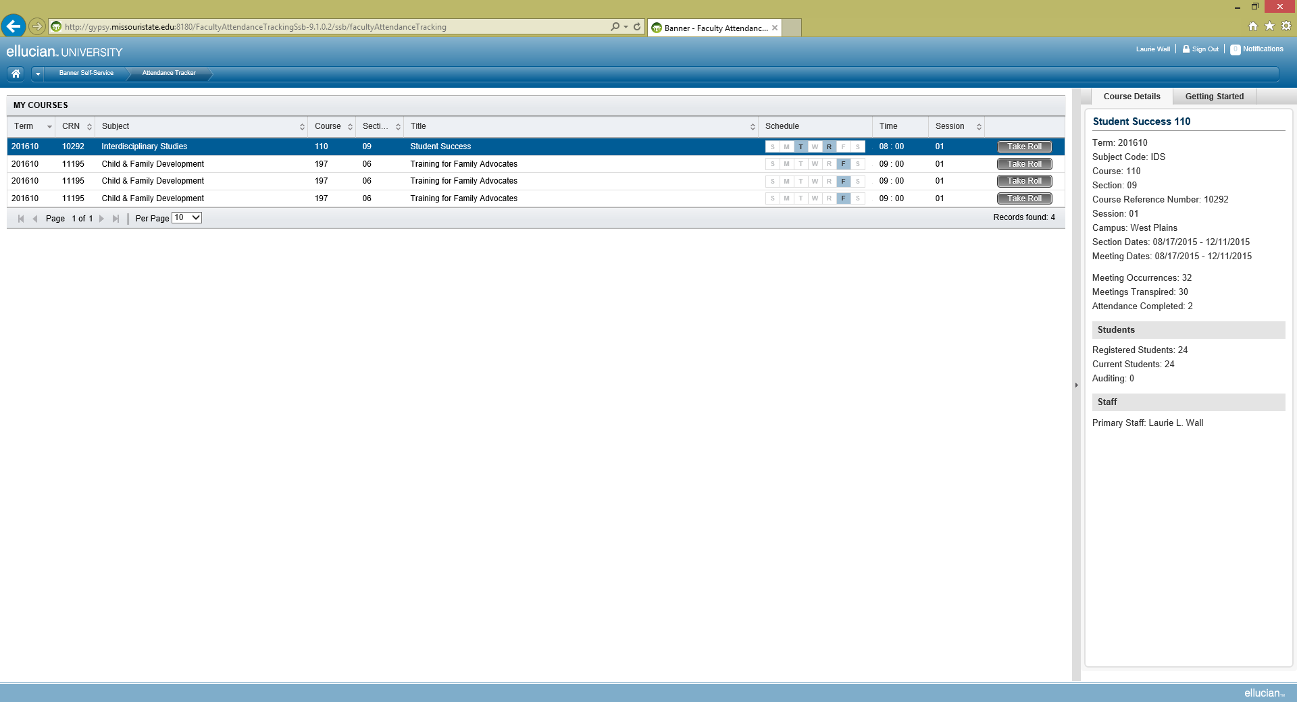

- Locate the row for the class you wish to enter attendance information and click on the Take Roll button.
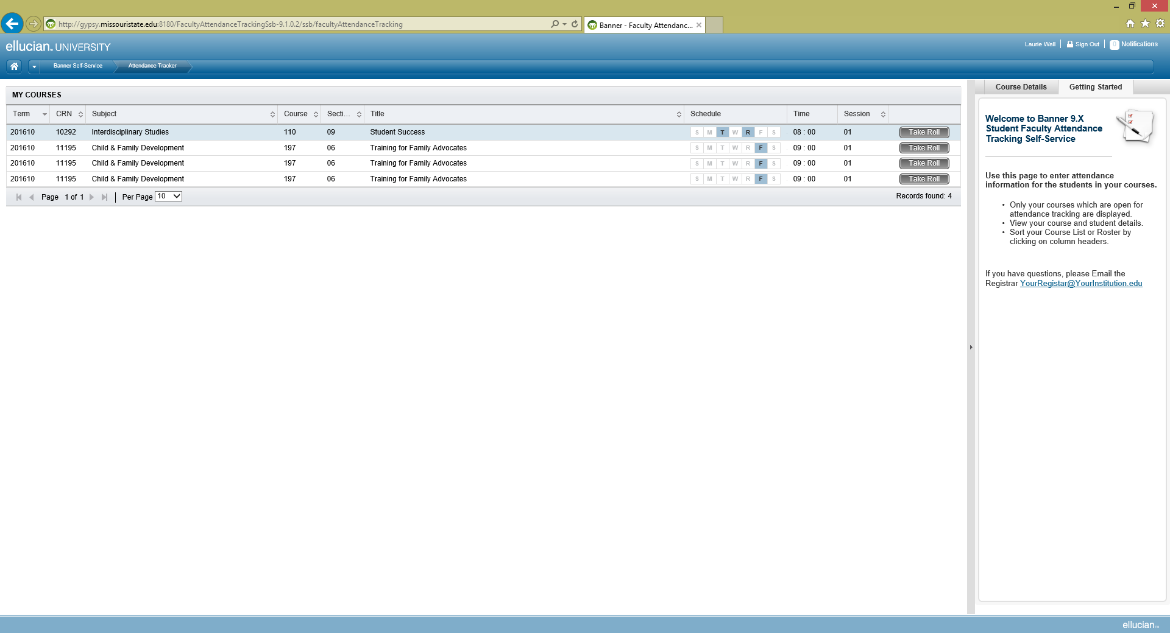
- You will see a roster with each student in your class. You have the option of marking each student individually or choosing to mark everyone present and then simply check the students who are absent.
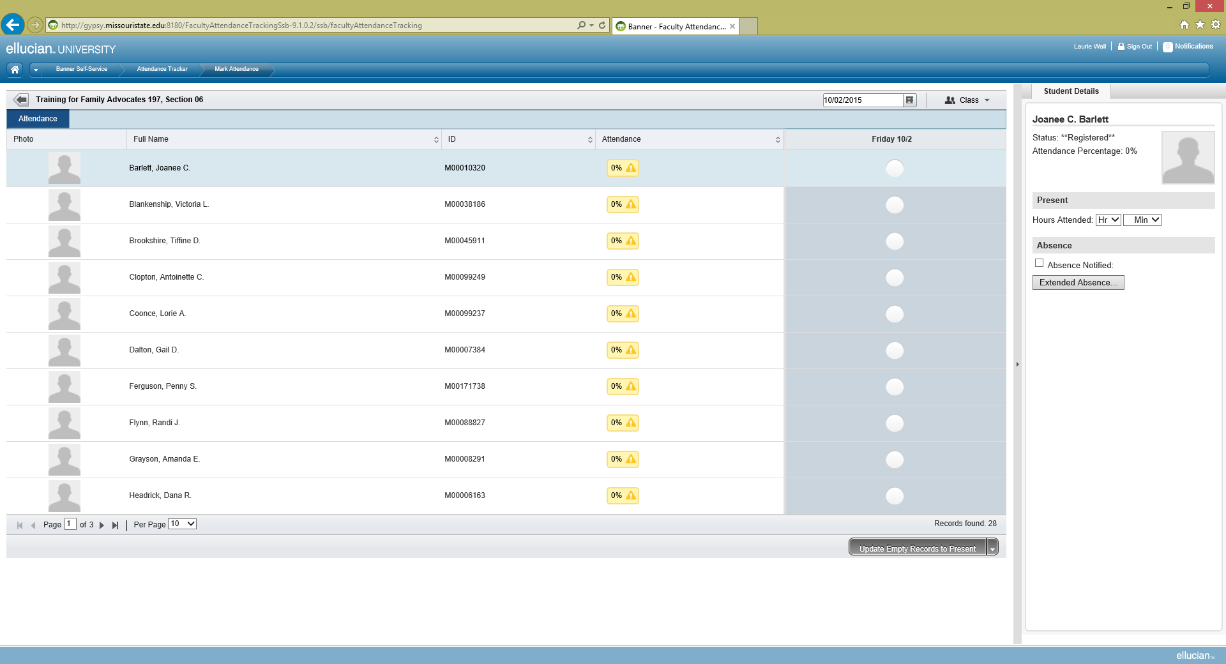

- To mark all students present click on the tab at the bottom right hand side of the screen. You are presented with these options. Choose the option you would like to use. Then click on the button to perform the function.
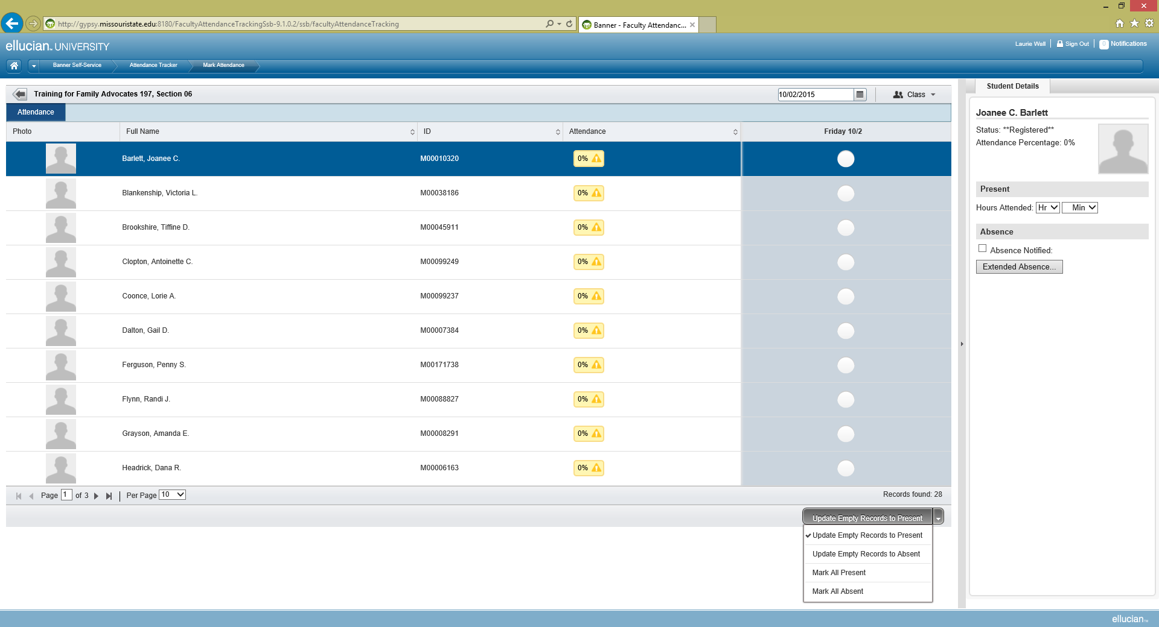

- Notice at the bottom left hand side of the screen you will see how many pages you will need to mark for this class. The system will default to 10 students per page. You may wish to change this to 50 per page so that you will only need to click the button once to update all students. (Obviously, if you have more than 50 students in your class, you will need to go to the next page and click the Update button again.)
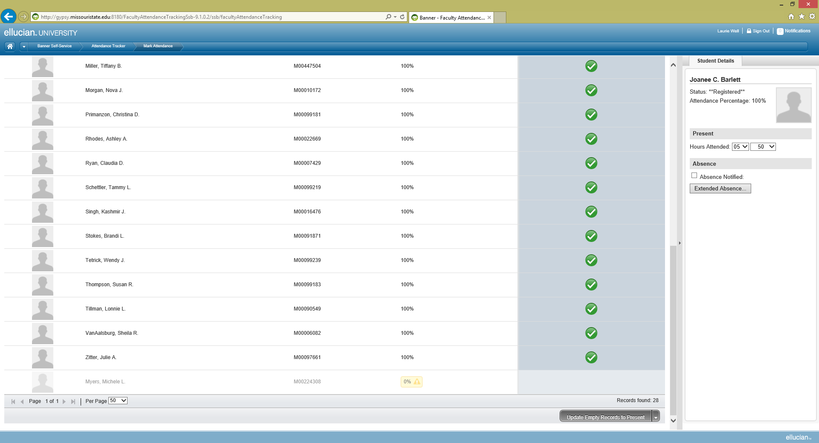

- Next mark students who are absent by clicking on that student’s record. Once you do this, you will see that that student’s percentage of attendance changes. This is based on the number of class meetings for this course.
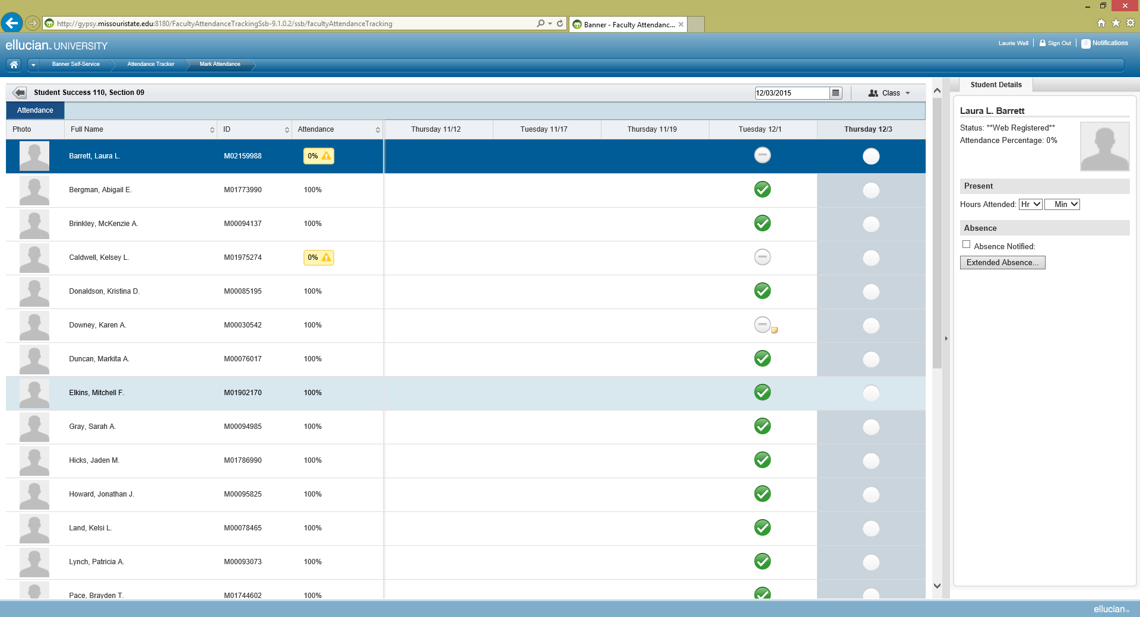

Also, on the left hand side of this roster you will see information about each student and you can note that a student has contacted you about an absence and make a note about the absence. (Note that for the date of the class meeting, there is an icon for that student. If you hover over it, it will reveal the note you made regarding the absence.)
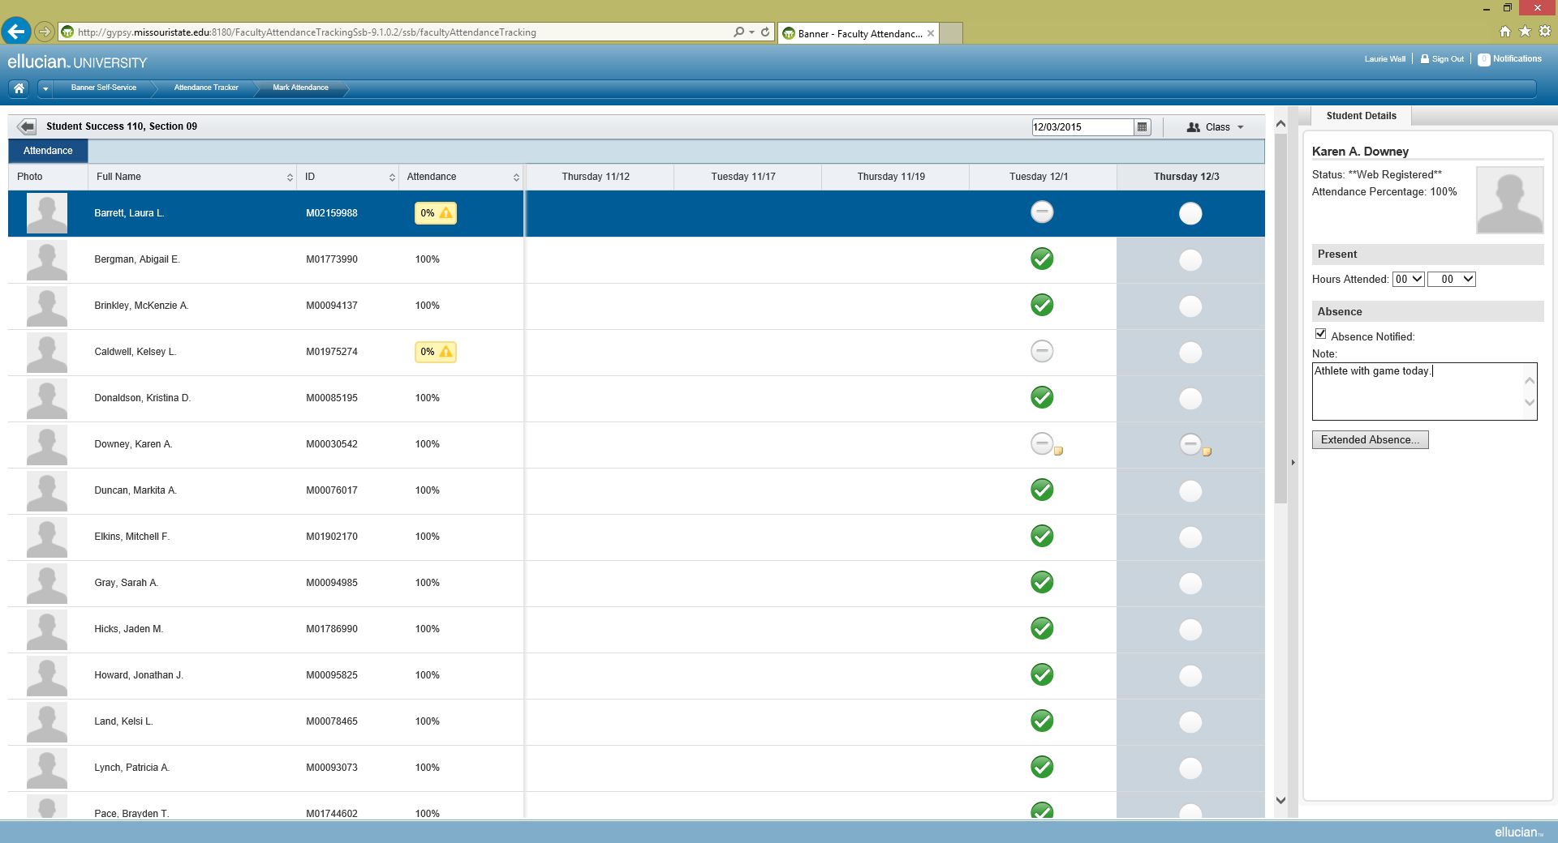

- Once you have completed taking attendance for the class meeting. Click on the Class button on the top right hand corner of the screen. You are given the option to update the Last Date of Attendance for this course. Please choose this option so this information is transferred over into Banner and the Financial Aid office can easily track the last date of attendance for return to Title IV monies. This is a very important feature to this module and it is critical that we do this step.
(Notice that there is also an option under this button to Cancel a class meeting.)
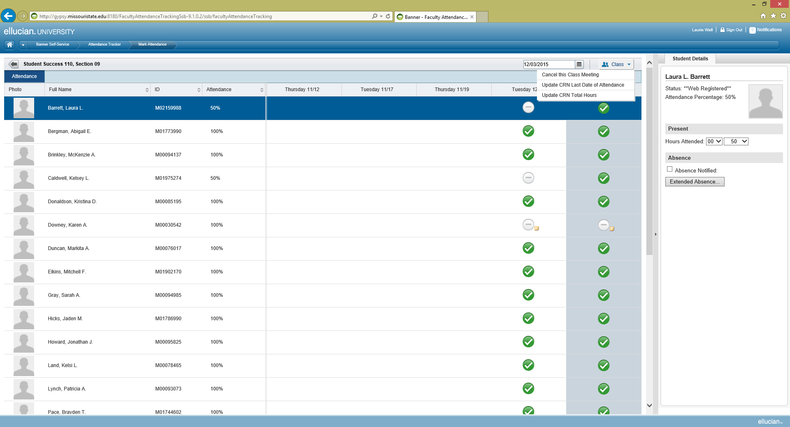

- To return to your list of courses just click the back arrow at the top left of the screen. Then repeat these steps for each of your classes.

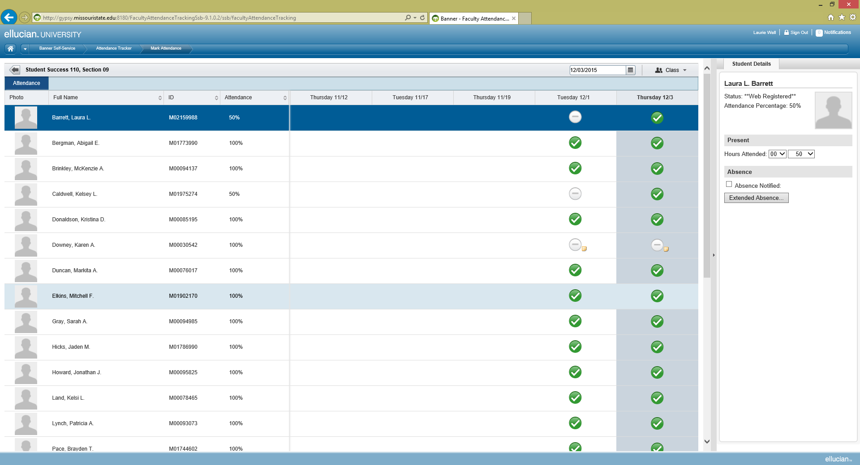

- Some Tips and Tricks:

- You can rearrange the columns of the roster by simply clicking and sliding the column to the location you’d like.
- The photos of students for the rosters are a coming attraction. We just have to create the file for this option.
- You can export the roster to an Excel spreadsheet if you’d like. (If this is something you want to do just contact Jill for specific instructions.)
- You can cancel a class meeting using this tool.
- Students will be able to see information about absences and the percentage they have attended as well as cancelled classes.
- The class dates are pulled from the Banner database and so there will not be attendance dates for when we are not in session such as Spring Break or holidays.
- You may do attendance tracking on your tablet or smartphone as well as a laptop or desktop computer.

