How to Grant a Registration Override
- You will only have access to grant overrides for classes for which you are the instructor of record. Departments have established guidelines for how overrides should be handled for their courses ranging from not authorizing faculty to grant any overrides to authorizing faculty to grant any type of override. Please follow the guidelines established by your department. If you are allowed to grant overrides which exceed the close level of a class, make sure that you are not exceeding the room's fire code capacity.
- Go to My Grizzly Den and enter your BearPass Login and password.
- Click the My Teaching/Advising Tab.
- On the Advisor Resources channel, choose Registration Overrides.
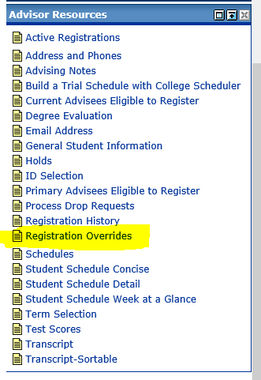
- Select the appropriate term and click Submit.
- Under Student and Advisee Query, enter the Last Name and First Name of the student. This information is not case sensitive and you may list only a partial name OR enter the student’s M#. Choose the radio button All for this search. Click the Submit button.
Explanation of Search Types
  - Students: only searches for students in your courses
  - Advisees: only searches for students on your advisee list
  - Both: searches for students in your courses and on your advisee list
  - All: searches for all students in database
- Choose the appropriate student from the drop down list and click Submit.
- You are taken to the Registration Overrides screen*. Use the drop down lists to choose the type of override, and the particular course** that the override applies to, and then click Submit. You can provide up to three overrides for the same student at the same time.
  - If you scroll down on this screen, you can see any overrides that you may have already granted, and the student's current enrollment for the term.
  - In the course list, you will only see those sections which you are assigned to teach. If a student needs an override for another class, they will need to get that override through the appropriate instructor of the department.
- You will see a verification screen. Make sure the override(s) is correct, and click on Submit. If you see an error, use your browser's back button to return to the previous screen to make changes.
- You will see a confirmation message.
